Guided Reading Curriculum for US and World History
Atkinson 2016
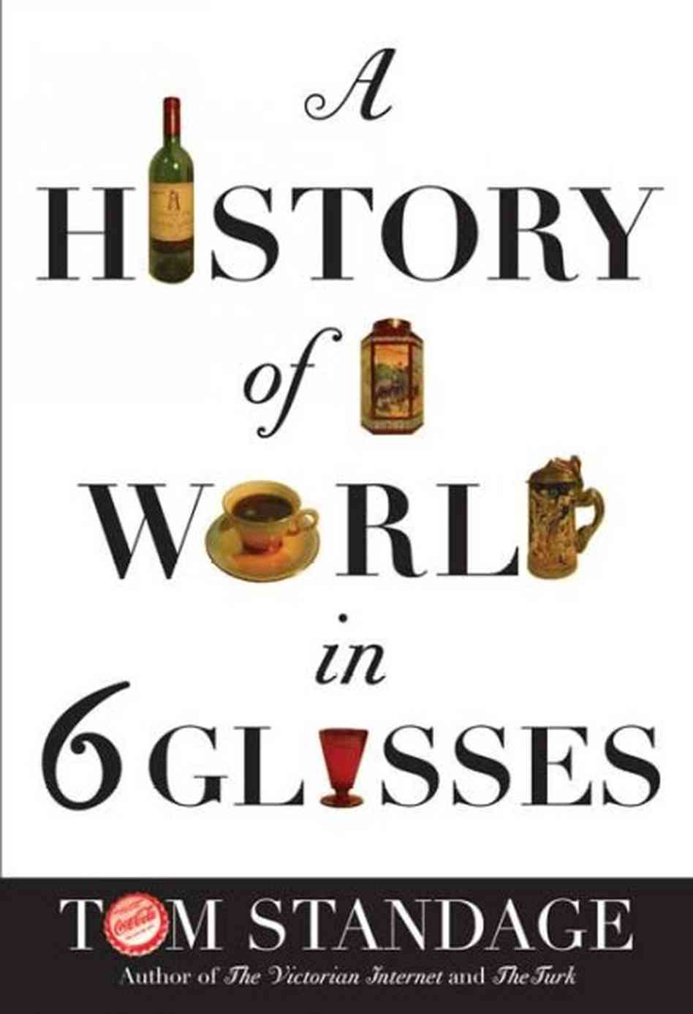
A History of the World in Six Glasses
By Tom Standage
Guided Reading
US History Version
PDF available at: http://east.dpsk12.org/wp-content/uploads/2013/08/6-Glasses-Bookpdf.pdf
A History of the World in Six Glasses provides essential evidence for United States History in three sections, Spirits, Tea and Coca-Cola. The following is a breakdown of each of the essential sections, removing non-relevant to the U.S. curriculum information. Included are questions for students to answer during readings for flipped classroom discussion, or in class guided reading activities. Pre-2017 Georgia Standards have been included with each question, and can easily be adapted to future standard updates.
Spirits in the Colonial Period
Chapter 5: High Spirits, High Seas p: 93-111
- Examine the connection between the process of distillation and the Age of Exploration. 2A
- What triggered the Age of Exploration? What allowed Europeans to explore these greater distances? 2A
- Why had Europeans not used “mass slavery” since Roman times, prior to the Age of Exploration? 2B
- What arguments were fabricated as attempts to vindicate the enslavement of millions of people? 2B
- Slavery in the New World grew exponentially due to the production of which crop? 2B
- Why did Europeans use African slaves as opposed to Native American labor? 2B
- How many Africans were transported to the New World? How many others died before ever reaching the New World? 2B
- Which items were traded between Europeans and Africans in exchange for slaves? 2A-B
- Explain the significance of alcohol, such as brandy, to the Atlantic slave trade. 2A-B
- Upon their arrival in Barbados, what did the English attempt to profit from and why? 1A
- Explain the derivation of the term “rum”.
- How did rum cement Triangular Trade? 2A
- Explain how rum was “the result of the convergence of materials, people and technologies from around the world.” 2A-B
Chapter 6: The Drinks That Built America p: 112-129
- What was England’s original intent for the lands of the American colonies? 2A
- What resources did colonists expect to find in abundance in the colonies, from which they hoped to earn great wealth? 2A
- What did the Europeans NOT find in the colonial lands of America? 2A
- List several hardships faced by the earliest British colonial settlers. 1A
- In 1620, which group came to the colonies? Where were they headed? Where did they actually end up? Who was their leader? 1B
- Virginian colonists eventually settled on what production as a source of income? 1A
- Rum consumption was implemented as a custom for which social acts?
- Explain the importance of rum to the New England economy in the 1600s. 1B
- Describe the connection between rum and the Atlantic Slave Trade. 1B-2B
- What was the driving force behind the creation of the Molasses Act? (Salutary Neglect)
- How did colonists respond to the passing of the Molasses Act? (Salutary Neglect)
- Explain how the colonists’ non-compliance in the Molasses Act was a sign of things to come in the American Revolution. (Salutary Neglect)
- Describe the global extent of the French and Indian War. 3A
- What was the purpose of the Sugar Act? 3A-B
- Why did the colonists argue that they should not have to abide by the Sugar Act? 3B
- List other taxes/acts that angered the colonists. 3B
- Describe the Boston Tea Party and subsequent Tea Parties. 3B
- When did the early American settlers switch from rum to whiskey? Why did they switch? 5E
- How did Alexander’s plan to help pay off the national debt involve whiskey? 5E
- What was the argument against the Whiskey Tax? 5E
- How did Washington address the Whiskey Rebellion? 5E
- How did the Federal Government’s reaction to the Whiskey Rebellion create a “defining moment” for American history? 5E
Tea and the British Empire
Chapter 10: Tea Power p: 198-220
- Define the Industrial Revolution based on the text. 7A
- How long did it take for the United States to reach Britain’s level of industrialization? 7A
- Why did the colonists smuggle tea into the colonies as opposed to purchasing it from their own British counterparts? 3B
- Why did Britain impose the Tea Act of 1733? 3B
- What was the colonial reaction to the Tea Act? 3B
- Describe the Boston Tea Party and subsequent tea parties. 3B
- Explain the Coercive Acts. 3B
- Why did American’s switch from tea to coffee as their drink of choice?
Coca-Cola and the Rise of America
Chapter 11: From Soda to Cola p: 223-249
- Describe the American System. 7A
- What was the first product of the American system? 7A
- What gave America a base for mass marketing and mass production? 16B
- What connected the United States after the Civil War in terms of economics? 11A
- Explain the competition between the United States and the Soviet Union during the Cold War. 20
- What led to the growth in “medical” products following the Civil War? 11A
- Explain how the Temperance movement impacted the growth of Coca-Cola. 7C
- What was the purpose of the Pure Food and Drug Act, and what was its impact on Coca-Cola? 13A
- What effect did Prohibition have on Coca-Cola? 15D
- What caused Coca-Cola to thrive during the Great Depression? 17
Chapter 12: Globalization in a Bottle p: 250-265
- What did Washington argue in his farewell address? 5E
- What caused the United States to become involved directly in WWII? 19B
- Explain how rationing worked during WWII and its impact on Coca-Cola. 19D
- How did the United States respond to the Soviet blockade of West Berlin? 20A
- Describe how Coca-Cola was seen as a negative symbol by countries in opposition to the United States. Include examples from WWII, the Cold War and Middle Eastern conflicts.

